Horizontal Line
# Source: AI Source: Provided by: [Data Path: Persons Table -> ID Column: 1, Name_En Column: Motasem Essam] -> From: [ChatGPT] on [7/25/2026]
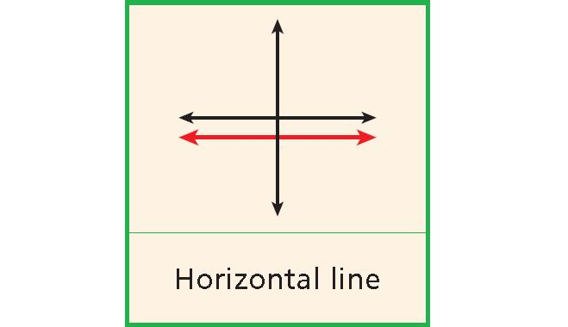
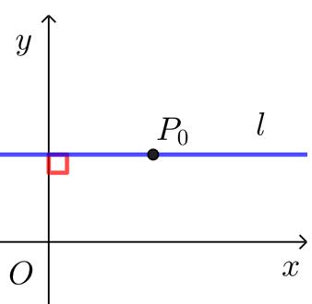
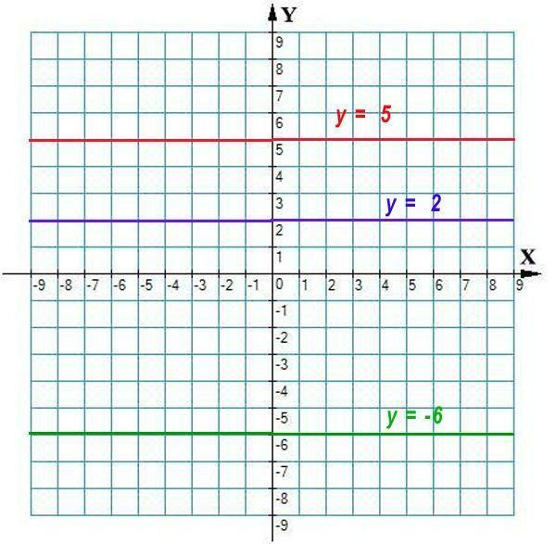
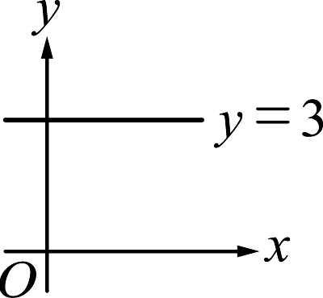
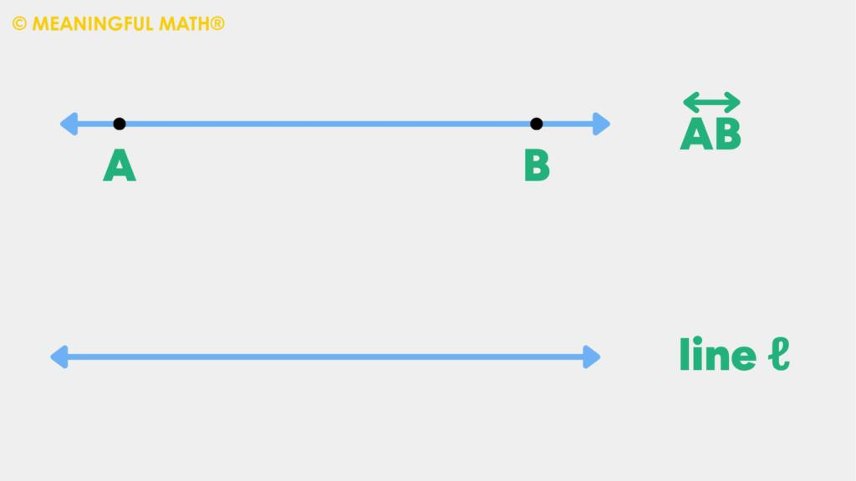
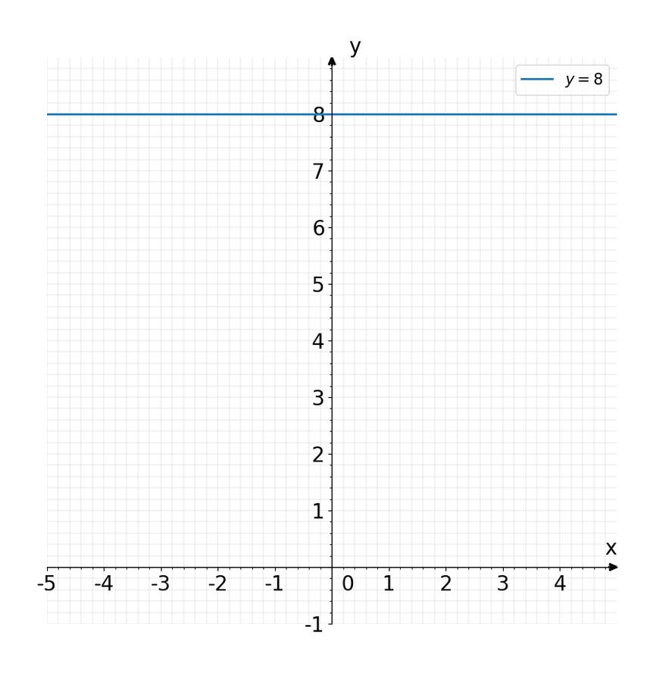

Definition
# Source: AI Source: Provided by: [Data Path: Persons Table -> ID Column: 1, Name_En Column: Motasem Essam] -> From: [ChatGPT] on [7/25/2026]
A Horizontal Line is a straight line that runs from left to right (or right to left) and is parallel to the horizon. Every point on a horizontal line has the same vertical coordinate (y-coordinate).
In coordinate geometry, a horizontal line has a slope of zero.

Characteristics
# Source: AI Source: Provided by: [Data Path: Persons Table -> ID Column: 1, Name_En Column: Motasem Essam] -> From: [ChatGPT] on [7/25/2026]
A horizontal line:
- Extends infinitely in both directions.
- Is parallel to the horizon.
- Has a constant y-coordinate.
- Has a slope of 0.
- Is perpendicular to every vertical line.

Illustration
# Source: AI Source: Provided by: [Data Path: Persons Table -> ID Column: 1, Name_En Column: Motasem Essam] -> From: [ChatGPT] on [7/25/2026]
←────────────────────────────────→

Coordinate Geometry
# Source: AI Source: Provided by: [Data Path: Persons Table -> ID Column: 1, Name_En Column: Motasem Essam] -> From: [ChatGPT] on [7/25/2026]
A horizontal line is represented by the equation:
$$y=c$$
where:
- $c$is a constant.
Example:
$$y=4$$
This means every point on the line has a y-coordinate equal to 4.

Graph Example
# Source: AI Source: Provided by: [Data Path: Persons Table -> ID Column: 1, Name_En Column: Motasem Essam] -> From: [ChatGPT] on [7/25/2026]
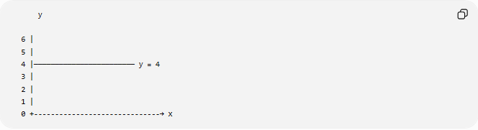
y

6 |
5 |
4 |──────────────────────── y = 4
3 |
2 |
1 |
0 +------------------------------→ x

Slope
# Source: AI Source: Provided by: [Data Path: Persons Table -> ID Column: 1, Name_En Column: Motasem Essam] -> From: [ChatGPT] on [7/25/2026]
The slope of a horizontal line is:
$$m=0$$
because there is no vertical change as the horizontal position changes.

Examples
# Source: AI Source: Provided by: [Data Path: Persons Table -> ID Column: 1, Name_En Column: Motasem Essam] -> From: [ChatGPT] on [7/25/2026]
Examples of horizontal lines include:
- The horizon.
- The x-axis.
- A shelf.
- The top edge of a table.
- A calm water surface (idealized).

Properties
# Source: AI Source: Provided by: [Data Path: Persons Table -> ID Column: 1, Name_En Column: Motasem Essam] -> From: [ChatGPT] on [7/25/2026]
A horizontal line:
- Has a constant y-coordinate.
- Has slope equal to zero.
- Is parallel to the x-axis.
- Never intersects another horizontal line unless they are the same line.
- Is perpendicular to all vertical lines.

Applications
# Source: AI Source: Provided by: [Data Path: Persons Table -> ID Column: 1, Name_En Column: Motasem Essam] -> From: [ChatGPT] on [7/25/2026]
Horizontal lines are used in:
- Plane Geometry
- Coordinate Geometry
- Engineering
- Architecture
- Construction
- Surveying
- CAD (Computer-Aided Design)
- Computer Graphics
- Technical Drawing
- Robotics

Advantages
# Source: AI Source: Provided by: [Data Path: Persons Table -> ID Column: 1, Name_En Column: Motasem Essam] -> From: [ChatGPT] on [7/25/2026]
Studying horizontal lines helps to:
- Understand coordinate systems.
- Analyze slopes.
- Construct geometric figures.
- Create engineering drawings.
- Model level surfaces.

Limitations
# Source: AI Source: Provided by: [Data Path: Persons Table -> ID Column: 1, Name_En Column: Motasem Essam] -> From: [ChatGPT] on [7/25/2026]
A horizontal line:
- Represents only one orientation.
- Cannot model inclined or vertical directions.
- Has no change in vertical position.

Comparison with Other Types of Lines
# Source: AI Source: Provided by: [Data Path: Persons Table -> ID Column: 1, Name_En Column: Motasem Essam] -> From: [ChatGPT] on [7/25/2026]
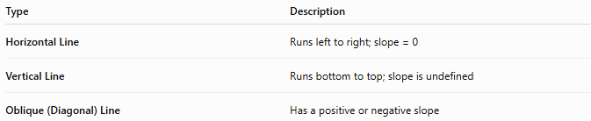
Type | Description
Horizontal Line | Runs left to right; slope = 0
Vertical Line | Runs bottom to top; slope is undefined
Oblique (Diagonal) Line | Has a positive or negative slope

Key Points
# Source: AI Source: Provided by: [Data Path: Persons Table -> ID Column: 1, Name_En Column: Motasem Essam] -> From: [ChatGPT] on [7/25/2026]
- A Horizontal Line is parallel to the horizon.
- It has the equation:
$$y=c$$
- Its slope is:
$$m=0$$
- All points on the line have the same y-coordinate.
- Horizontal lines are widely used in geometry, engineering, architecture, surveying, CAD, and computer graphics.

Conclusion
# Source: AI Source: Provided by: [Data Path: Persons Table -> ID Column: 1, Name_En Column: Motasem Essam] -> From: [ChatGPT] on [7/25/2026]
A Horizontal Line is a straight line that extends infinitely from left to right while maintaining a constant vertical position. In coordinate geometry, it is represented by the equation $y=c$and has a slope of zero, making it parallel to the x-axis and perpendicular to every vertical line. Horizontal lines are fundamental in plane geometry, coordinate geometry, engineering, architecture, construction, surveying, CAD, robotics, and computer graphics, where they are used to represent level surfaces, reference axes, and horizontal alignments.

